State Street
International RTPS
Full Payment Engine
Solution Scope Document
December 6, 2023
Version 0.1
Confidential

Table of contents
Table of contents II
1. INTRODUCTION 1
1.1 Reference Documents 1
1.2 Document Control 1
2. Client overview 2
2.1 Business Objectives 2
3. Current Business processing description 3
3.1 Current System Context & Diagram 3
3.2 Current System Volumes 4
4. proposed solution scope 5
4.1 Proposed Solution Context & Diagram 5
4.2 Proposed Hardware (?) 5
4.3 SWIFT ISO and FIN Gateway Interface 5
4.4 Fedwire ISO Interface 5
4.5 CHIPS ISO Interface 5
4.6 Additional RTGS ISO Interfaces 6
4.7 Internal Bank System Interfaces 6
4.7.1 Sanctions Screening (OFAC) Integration 6
4.7.2 CRCU 6
4.7.3 Fraud 6
4.7.4 MPA (Memo Posting Authorization) 6
4.7.5 IBS 7
4.7.6 Payment Initiation Channels 7
4.7.7 Autotrieve (?) 7
4.7.8 FX Rate Server 7
4.7.9 ACE Pelican 7
4.7.10 Intelli TRACS 7
4.7.11 Transaction Status Interface (TSI) 8
4.7.12 Internal RTPS Endpoints 8
4.8 Customizations 8
4.9 End of Day Extracts / Reports 8
4.10 Disaster Recovery (in or out of this SSD?) 8
5. branch (or bank) conversion 9
6. extra section if needed 10
7. Assumptions and Constraints 11

INTRODUCTION
This document will provide a solution scope overview of State Street’s request for an International RTPS Full Payment engine.
The current Conduit Model(s) will result in a target state model where RTPS will function as the full payment engine including upstream integration with initiation channels and a posting interface with Transact as the banking system. ISO 20022 will be the messaging standard with rich MX data content persisted through the complete message flow.

Reference Documents
Source | Document
State Street PowerPoint | International RTPS ISO 20022 Conduit Model to Full Payment Engine – 2023-11-09

Document Control
A description of the document revisions is shown below. Any changes of text from one version to another are indicated with the symbol “|” in the outside margin.
Modification History
Version | Date | Author | Comment
0.1 | 12/06/2023 | D. Scarmozzino | Initial version

Client overview
State Street is engaging ACI to implement the International RTPS as the full payment engine. State Streets evolution of their existing Conduit environments.

Business Objectives
State Street objectives for this full payment engine is the evolution of their conduit environments to a full payment environment. Major objectives, to utilize the rich functionality within RTPS, to have continuity for multiple facets of payment processing such as but not limited to sanctions screening, account validation, balance checking, to name a few.

Current Business processing description

Current System Context & Diagram
In the current environment State Street’s MTS deployment is described in the following diagrams.
State Street runs MTS version 6.x (in all current environments).
Today State Street has 4 different banks in one RTPS environment and a separate US RTPS environment for CHIPS and FED.
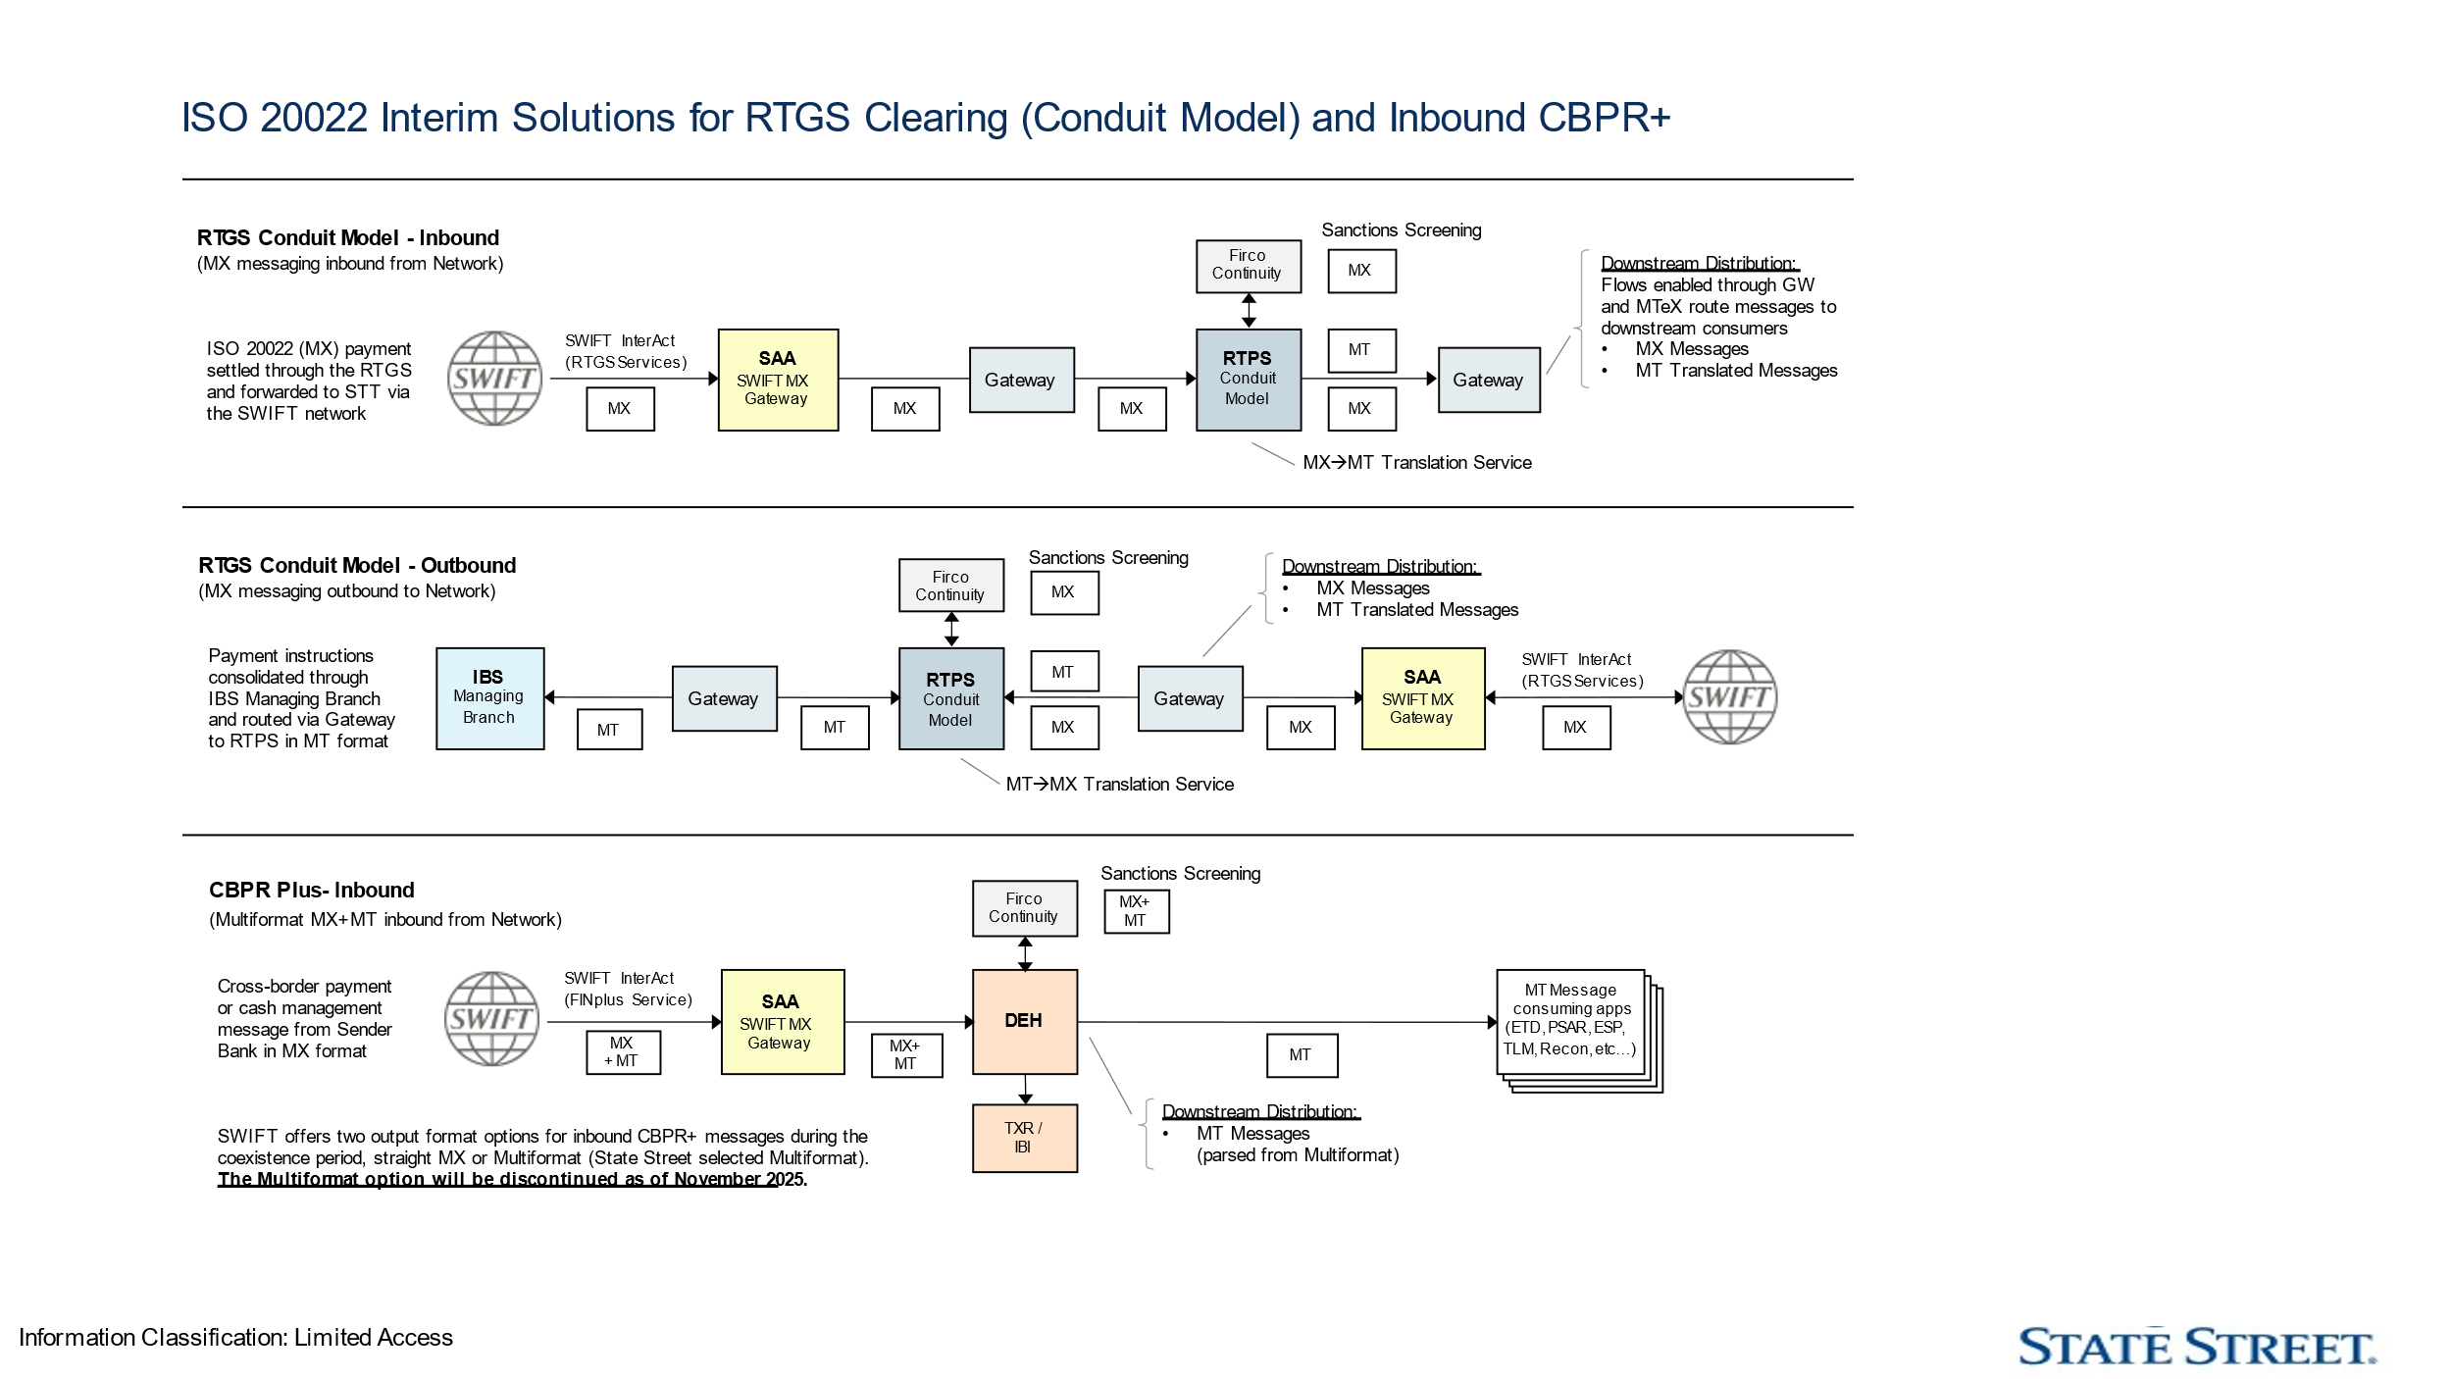
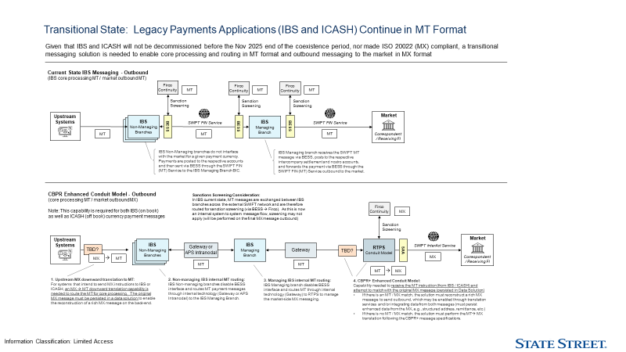

Current System Volumes
State Street processes domestic and international payments with SWIFT being the primary carrier (?) of traffic. The table below reflects the payment / message type and average daily volumes.
Payment Type | Outgoing | Incoming
CHIPS
FedWire
CHAPS
HK CHATS
Target2 (A2A)
LYNX/RITS

proposed solution scope
This section describes the implementation requirements for State Street Bank to achieve their International RTPS Full Payment engine.

Proposed Solution Context & Diagram
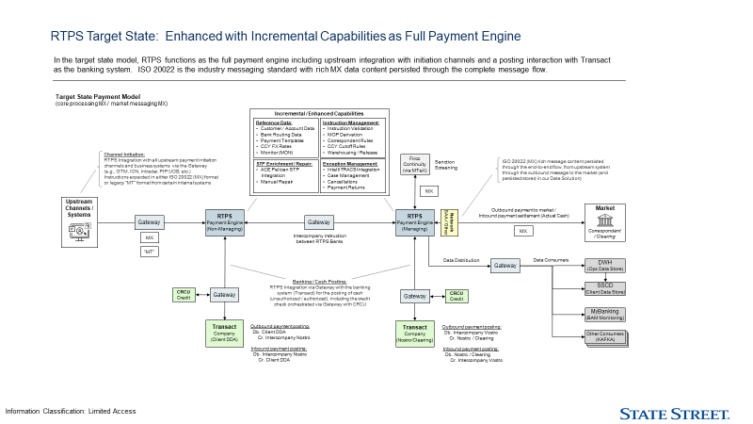

Proposed Hardware (?)

SWIFT ISO and FIN Gateway Interface
[Description of requirements for banks that use a non-ACI SWIFT interface, delete this section if not applicable]
.

Fedwire ISO Interface
[Description of requirements for banks that use the Fedwire interface, delete this section if not applicable]

CHIPS ISO Interface
[Description of requirements for banks that use the CHIPS interface, delete this section if not applicable]

Additional RTGS ISO Interfaces
UK CHAPS
HK CHATS
LYNX
RITS
Target2 (A2A)
OTHER

Internal Bank System Interfaces
[Describe each interface, highlight where customer have made specific choices, remove sections that don’t apply to State Street]

Sanctions Screening (OFAC) Integration
Firco

CRCU
CRCU – Credit Risk Central Utility (Credit Decisioning by customer) Account officer review – relevant to the customer side

Fraud
[Fraud Scoring]

MPA (Memo Posting Authorization)
Hogan in the RTPS US environment supporting NY and Boston Branches is being replaced with Transact. There could be a period of time where Hogan and Transact are needed
Transact Company – Client DDA – non-managing
Outbound payment posting – Debit Client DDA, Credit Intercompany Nostro
Inbound payment posting – Debit Intercompany Nostro, Credit Client DDA
Transact Company – Nostro Clearing – managing
Outbound payment posting – Debit Intercompany Vostro, Credit Nostro / Clearing
Inbound payment posting – Debit Nostro / Clearing,

IBS
Currently IBS is both a payment system and posting system
IBS Managing Branch is the intermediary for themselves - other SS Branches -
Internal intermediary process / relationship

Payment Initiation Channels
GTM
ION
Intrader
PIP/UOB
Other
Instructions expected in ISO 20022 and legacy MT from certain internal systems

Autotrieve (?)
[CIF lookup interface]

FX Rate Server
[Interface to query FX rates in real time]

ACE Pelican
STP integration
Expand ACE STP to other Branches (like what is in the US today)
Correspondent Rules
Currency Cut off rules

Intelli TRACS

Transaction Status Interface (TSI)
Data Distribution using TSI (in the US only?)
Currently one TSI interface and State Street gateway distributes to other systems:
DWH (Ops Data Store)
SSCD (Client Data Store)
Other Consumers (KAFKA)
BAM (?) Business Activity Monitoring (through workflow monitor?) (is this TSI?)

Internal RTPS Endpoints
The MTS/UPF solution make use of some internal endpoints which must be configured for the solution.
• MTS Adaptor Endpoint – bi-directional endpoint interacts with MTS from the UPF layer (One endpoint)

Customizations

End of Day Extracts / Reports

Disaster Recovery (in or out of this SSD?)
The deployment of MTS + RTPF will follow the same DR strategy as for the MTS technology stack. This is an Active / Hot Standby topology where one site is active at a time. When State Street fails over to their DR site the entire application including all components will be switched from stand by to hot status via operational command.

bank conversion
This section is to list each bank, represented by a ‘network scheme’, and identify requirements in appropriate, agreed upon Phases.
Today State Street has two RTPS environments:
One RTPS environment has 5 ‘banks’:
CHAPS UK,
CHATS HK,
LYNX Canada,
RITS Australia,
Target2 Germany
Second RTPS environment in the US with 2 ‘banks’:
CHIPS
FED
Remaining 2024 Scope – just for estimates? – when does the work need to start?
PHASES (order is to be determined)
▪ Implement the Int'l RTPS conduit model environment for all (existing and new) SSB payment branches (banks / networks)
What are the new banks / networks? What are the timelines?
▪ Implement Int'l RTPS as the full payment engine
Does this mean Adding Interfaces; Transact (account validation, balance checking, posting), Fraud, Sanctions, other
What about CBPR+?
▪ Implement US RTPS integration with Transact
(where, in what environment, the RTPS Full Payment Engine environment?)

▪ Product dependent:
Enhanced / Structured data requirements,
Any new Networks,
SEPA,

US and Global
US what’s needed
(FED ISO – separate project / own contract)
Hogan to Transact
ACI is proposing current MPA – RFML External Interface document
Need requirements from State Street to determine where gaps / customizations are needed.
- What data would RTPS be required to send to the posting interface?
- Are 2 levels of posting required - unauthorized post followed by authorized post - as soon as payment system gets the payment order and not released until tomorrow want a pre-posting message sent to Transact - that is an unauthorized so Transact knows about the transaction and then tomorrow when the payment is to be released do the real post or the authorized post - hard post to the respective accounts
- What about end of day accounting file – if not needed posting requests such as GL would have to be added to the posting data
- Will both Hogan and Transact be needed (for a period of time) – if so how to identify which accounts go where
- Is the interface for posting only, no balance authorization
- Check digit routine
- Account Lengths

Global what’s needed
Conduit model to Payment Model
- What environment is surviving (what environment will be configured to be the full payment engine)
- What banks / what networks
- FX enabled
- Transact
- All other interfaces to be identified and their roles
- Re-do what was done to make RTPS a conduit model
- 12 Banks
- FX Enabled
- MPA – Transact (what does Transact do today?)
- All other interfaces to be identified
- Re-do what was done to make RTPS a conduit model

Assumptions and Constraints
This section describes the assumptions and constraints for the bank’s project
- Installation will be on bank premises (location?)
- FED ISO 20022 needs to be planned to ensure State Street meets Fed ISO March 2025

© Copyright ACI Worldwide, Inc. 2023
ACI, ACI Worldwide, ACI Payments, Inc., ACI Pay, Speedpay and all ACI product/solution names are trademarks or registered trademarks of ACI Worldwide, Inc., or one of its subsidiaries, in the United States, other countries or both. Other parties’ trademarks referenced are the property of their respective owners.

